A CASE-STUDY BASED REPORT
ON
Player Performance Prediction Using Regression and Gradient Boosting
submitted in partial fulfilment of the requirements for the Course
MACHINE LEARNING
BACHELOR OF TECHNOLOGY
in
A.Y.: 2026-27
by
G. Kevin Josh roll 2520030213
D. Ravi Teja roll 2520030379
Under the Esteemed guidance of
Mrs.Jyothsna Datti
Asst.Professor, Dept. of CSE




INDEX
Abstract
Introduction
Background
Motivation for the Project
Overview of the Work Carried Out
Scope and Responsible-Use Statement
Problem Statement
Case-Study Scenario
Central Case-Study Question
Formal Problem Definition
Objectives that Guide the Study
Assumptions and Limitations
Dataset and Exploratory Data Analysis
About the Dataset
Purpose of EDA
Preparation Steps Actually Performed
EDA Exploration - Implementation
Summary of EDA Findings
Algorithm Selection and Implementation

Conclusion

Signature of the Team members

Abstract
Player performance prediction is an important application of machine learning in sports. Coaches and teams need to understand how a player may perform in future matches to make better decisions about team selection, training, and player management. This case study, "Player Performance Prediction Using Regression and Gradient Boosting", predicts a continuous Player Performance Score from player statistics such as matches played, goals, assists, shots, shots on target, pass accuracy, and tackles.
The supplied dataset of 1,000 players is checked for missing values, duplicate records, and outliers, and is explored using descriptive statistics, histograms, and correlation analysis. It is then divided into 80% training data and 20% testing data. Two models, Linear Regression and Gradient Boosting Regression, are trained and evaluated using Mean Absolute Error (MAE), Mean Squared Error (MSE), Root Mean Squared Error (RMSE), and the R² score. On the test data, Linear Regression achieved an R² of 0.7843 and an RMSE of 4.15, while Gradient Boosting achieved an R² of 0.7506 and an RMSE of 4.46. Goals, matches played, shots on target, and assists were found to be the most influential statistics. The study shows how machine learning can support data-based analysis of player performance.
Introduction
Sports have become highly dependent on data and technology for improving team and player performance. Every player produces a large amount of information during matches, such as goals, assists, shots, passing accuracy, tackles, and the number of matches played. Studying this information can help coaches and teams understand player abilities and estimate how players are likely to perform.
Machine learning provides useful methods for analysing this data. In this project, Linear Regression and Gradient Boosting Regression are used to predict a numerical Player Performance Score from historical player statistics. Linear Regression provides a simple and interpretable baseline, while Gradient Boosting combines many small decision trees to learn more complex relationships. Both models are trained on historical data and tested on unseen data, and their results are compared using standard regression metrics.
Background
Sports analytics uses statistical and machine learning methods to convert match data into useful knowledge for coaches, scouts, and analysts. Regression is a natural approach when the quantity to be predicted is continuous, such as a performance score. Linear Regression models the target as a weighted combination of the input statistics, which makes the effect of each statistic easy to interpret.
Gradient Boosting is an ensemble technique in which decision trees are built one after another, and each new tree is trained to reduce the errors left by the previous trees. This allows the model to capture non-linear relationships and interactions between statistics. Comparing a simple baseline with a non-linear ensemble model is a common way to find out whether additional model complexity gives better predictions on a given dataset.
Motivation for the Project
Assessing players manually becomes time-consuming and inconsistent when many statistics must be considered together. A single statistic, such as goals alone, does not describe overall performance because several factors interact with one another. A machine learning model can combine all the available statistics and produce a consistent estimate of performance for every player.
Another motivation is to find out which statistics contribute most to performance, and to compare a simple model with a more advanced one on the same data. The answers can help coaches, sports analysts, and teams make data-based decisions about player selection, training, and development.
Overview of the Work Carried Out
The work began with loading the player performance dataset and examining its shape, column types, and descriptive statistics. The data was checked for missing values and duplicate records, and the spread of each attribute was studied using the IQR method for outliers. Distributions and correlations with the target were analysed using histograms and a correlation matrix.
The Player_ID column was removed, the seven player statistics were used as input features, and Player_Performance_Score was used as the target. The data was divided into training and testing sets in an 80:20 ratio. Linear Regression and Gradient Boosting Regression were trained on the training set and evaluated on the testing set using MAE, MSE, RMSE, and R². The results and the importance of each feature were then compared.
Scope and Responsible-Use Statement
The scope of this case study is limited to the supplied dataset of 1,000 player records and to the two selected models, Linear Regression and Gradient Boosting Regression. The purpose is to demonstrate how machine learning can estimate a player performance score from match statistics.
The predicted scores should be treated as decision-support information and not as the only basis for important decisions about a player. Factors such as injuries, opposition strength, tactics, and match context are not included in the data. The results are valid only for the supplied dataset and may change when the models are applied to other players or other sports data.
Problem Statement
Manual evaluation of players is time-consuming when many statistics are involved, and the factors that influence performance interact with one another, so no single statistic is enough. The problem addressed in this case study is to predict a continuous Player Performance Score from player statistics, and to compare a baseline Linear Regression model with a Gradient Boosting Regression model using standard regression measures.
Case-Study Scenario
Consider a sports team or analytics department that maintains statistics for a large number of players, including matches played, goals, assists, shots, shots on target, pass accuracy, and tackles. Coaches and analysts want a quick and consistent way to estimate each player's overall performance so that they can compare players, track development, and support selection decisions.
In this case study, the supplied dataset is analysed using exploratory data analysis, and two regression models are trained to predict the performance score. Their predictions on unseen players are compared to understand which model is better suited to this task.
Central Case-Study Question
How accurately can Linear Regression and Gradient Boosting Regression predict the Player Performance Score from the available player statistics, and which of the two models gives the better predictions on unseen data?
The study also asks which player statistics have the strongest influence on the predicted score.
Formal Problem Definition
The dataset contains 1,000 player records. Each record has seven numerical input attributes (MatchesPlayed, Goals, Assists, Shots, ShotsOnTarget, PassAccuracy, and Tackles) and one continuous target variable, Player_Performance_Score. The task is to learn a function that maps the input attributes of a player to the target score.
The models are trained on a training portion of the data and evaluated on a held-out testing portion using Mean Absolute Error, Mean Squared Error, Root Mean Squared Error, and the R² score. Lower values of MAE, MSE, and RMSE and a higher value of R² indicate better predictions.
Objectives that Guide the Study
The first objective is to analyse the player performance dataset and identify the statistics that are most strongly related to the performance score. The second objective is to clean and prepare the data and divide it into training and testing sets.
The third objective is to implement Linear Regression and Gradient Boosting Regression and evaluate them using MAE, MSE, RMSE, and R². The final objective is to compare the two models and identify the player statistics that contribute most to the predictions.
Assumptions and Limitations
The study assumes that the supplied dataset is accurate and that the seven player statistics contain enough information to estimate the performance score. It also assumes that the records are independent of one another and that the testing data represents players the models have not seen.
The main limitations are the size of the dataset, which has only 1,000 records, and the absence of contextual information such as injuries, opposition strength, and tactics. Only default settings of the models were used, and no extensive hyperparameter tuning was performed. The reported results come from a single 80:20 split, so they may vary slightly with a different split. The study is therefore a demonstration within the scope of the available data and not a complete player evaluation system.
Dataset and Exploratory Data Analysis
The project uses a player performance dataset in CSV format containing 1,000 player records and nine columns. Exploratory Data Analysis was carried out to understand the structure of the data, its quality, and the relationships between the player statistics and the performance score before any model was trained.
About the Dataset
Each row of the dataset represents one player. The Player_ID column is only an identifier, seven columns are numerical player statistics, and Player_Performance_Score is the continuous target variable. Table 1 describes the columns.
Column | Description
Player_ID | Unique identifier of the player
MatchesPlayed | Total matches played
Goals | Goals scored
Assists | Successful assists
Shots | Total shots attempted
ShotsOnTarget | Shots that were on target
PassAccuracy | Passing accuracy (%)
Tackles | Defensive tackles made
Player_Performance_Score | Target value to predict

Table 1: Description of dataset columns.
Purpose of EDA
The purpose of EDA is to understand the shape and data types of the dataset, verify its quality by checking for missing values and duplicates, study the distribution and spread of each attribute, detect outliers, and measure how strongly each statistic is related to the performance score. These findings guide the choice of input features and the preparation steps, and they help to interpret the model results later.
Preparation Steps Actually Performed
The dataset was loaded using Pandas and its shape, column names, data types, and descriptive statistics were inspected. A check of the data found no missing values and no duplicate records, and every Player_ID was unique, so no cleaning or imputation was needed. All input attributes were already numerical, so no encoding was required.
Outliers were identified using the IQR method. Goals had 20 outliers, Tackles had 7, Assists and ShotsOnTarget had 5 each, and PassAccuracy had 4, while MatchesPlayed, Shots, and the performance score had none. These values lie within realistic ranges for player statistics, so they were retained. The Player_ID column was dropped because it carries no predictive information. The remaining seven statistics were used as features and Player_Performance_Score as the target. The data was split randomly into 800 training records and 200 testing records using a fixed random state of 42 so that the results can be reproduced.
EDA Exploration - Implementation
Descriptive statistics were calculated for every numerical attribute, and the results are given in Table 2. The performance score ranges from 63.29 to 100.00 with a mean of 86.40 and a standard deviation of 8.54.
Attribute | Mean | Std Dev | Min | Max
MatchesPlayed | 30.34 | 11.98 | 10.00 | 50.00
Goals | 7.86 | 2.60 | 1.00 | 16.00
Assists | 4.99 | 2.30 | 0.00 | 15.00
Shots | 33.21 | 9.16 | 12.00 | 58.00
ShotsOnTarget | 17.90 | 6.21 | 4.00 | 39.00
PassAccuracy | 82.18 | 7.14 | 58.69 | 98.00
Tackles | 25.22 | 5.18 | 10.00 | 42.00
Score | 86.40 | 8.54 | 63.29 | 100.00

Table 2: Descriptive statistics of the dataset.
The distribution of the target variable was plotted as a histogram, shown in Figure 1. Most scores are concentrated around the mean, no player scores below 63, and a noticeable group of players sits at the maximum score of 100.
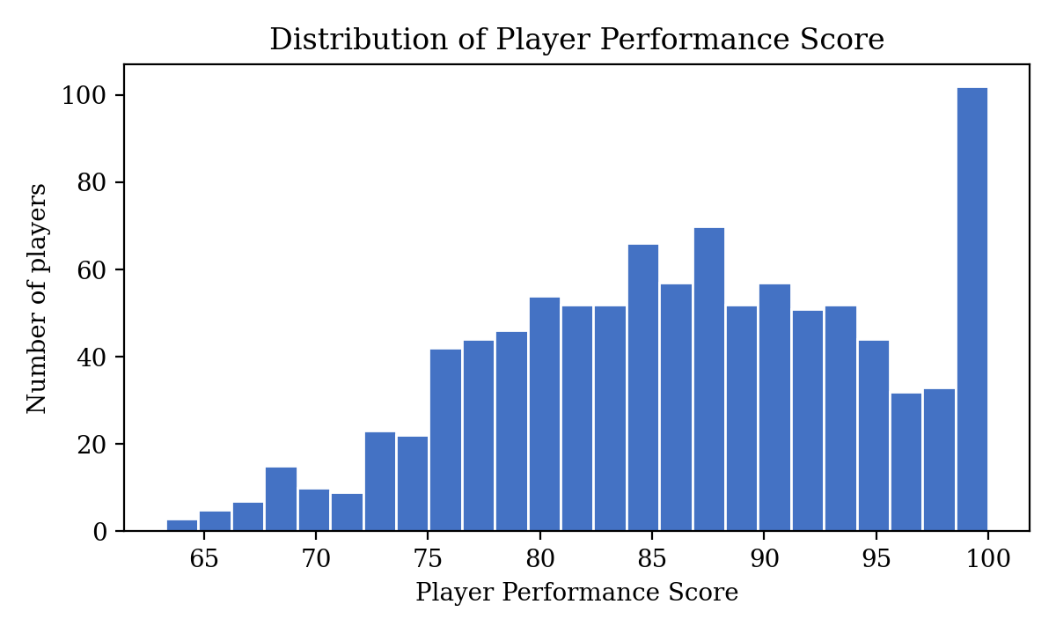
Figure 1: Distribution of the Player Performance Score.
A correlation matrix, shown in Figure 2, was used to study the relationship of each statistic with the target. Goals has the strongest correlation with the performance score (0.580), followed by ShotsOnTarget (0.477), Shots (0.463), MatchesPlayed (0.447), Assists (0.315), PassAccuracy (0.176), and Tackles (0.135). All correlations with the target are positive.
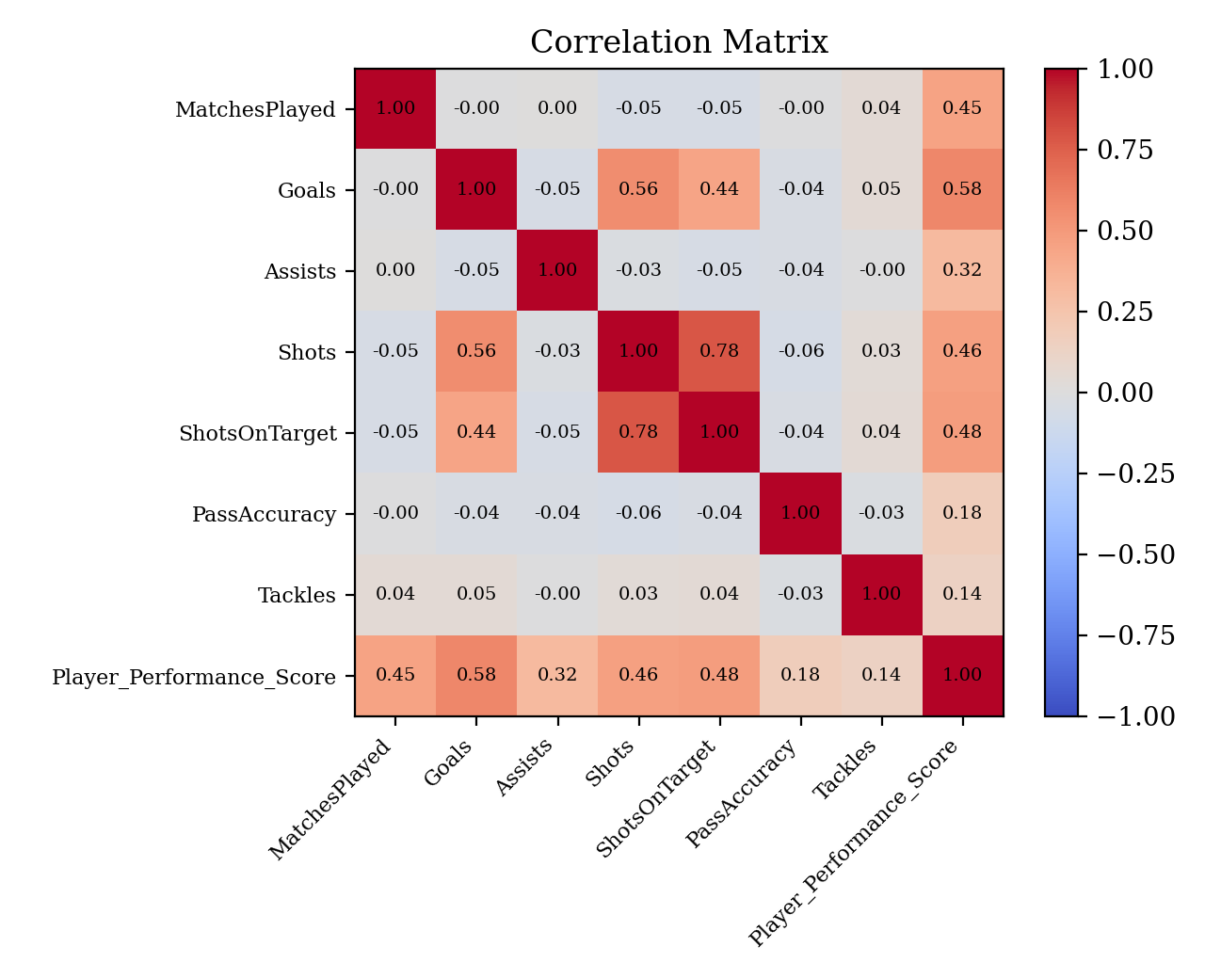
Figure 2: Correlation matrix of the player statistics.
Summary of EDA Findings
The dataset is clean, with 1,000 records, no missing values, and no duplicates. Outliers are present in a few attributes, but they are realistic and were retained. The performance score is spread between about 63 and 100 with a mean of 86.40.
Every statistic is positively correlated with the performance score. Goals is the most strongly related attribute, followed by shots on target, shots, and matches played, while pass accuracy and tackles have weaker relationships. No single statistic explains the score completely, which supports the use of a model that combines all the statistics.
Algorithm Selection and Implementation
The models were implemented in Python using Pandas and NumPy for data handling, Matplotlib for plots, and Scikit-learn for modelling and evaluation. The work can be run in Jupyter Notebook, Google Colab, or Visual Studio Code. Because the target is continuous, regression algorithms were selected.
Linear Regression was selected as a simple and interpretable baseline. It fits a linear relationship between the seven statistics and the performance score. The largest learned coefficients were for Goals (1.50) and Assists (1.36), followed by ShotsOnTarget (0.44), MatchesPlayed (0.33), PassAccuracy (0.25), and Tackles (0.15), while Shots had almost no effect (0.00) once the other statistics were included.
Gradient Boosting Regression was selected as a non-linear ensemble model that builds decision trees sequentially, with each tree correcting the errors of the previous ones. It was trained with the default Scikit-learn settings (100 trees, learning rate 0.1, and maximum depth 3). Its feature importance values were highest for Goals (0.344), MatchesPlayed (0.269), ShotsOnTarget (0.149), and Assists (0.143), and low for PassAccuracy (0.066), Tackles (0.016), and Shots (0.014).
Both models were trained on the 800 training records and evaluated on the 200 unseen testing records. The results are given in Table 3.
Metric | Linear Regression | Gradient Boosting
MAE | 3.40 | 3.68
MSE | 17.23 | 19.92
RMSE | 4.15 | 4.46
R² Score | 0.7843 | 0.7506

Table 3: Performance of the two models on the testing data.
Linear Regression achieved lower MAE, MSE, and RMSE and a higher R² than Gradient Boosting on this dataset. It explains about 78.4% of the variation in the performance score, compared with about 75.1% for Gradient Boosting, and its average absolute error is about 3.4 points on a score that ranges from 63 to 100. The result suggests that the relationship between the statistics and the score is largely linear, so the extra flexibility of Gradient Boosting did not give better predictions with default settings. Tuning the boosting parameters or using more data might change this outcome. Both models identify Goals as the most influential statistic, and both rank Assists, ShotsOnTarget, and MatchesPlayed above PassAccuracy and Tackles.
Conclusion
This case study demonstrated the use of machine learning to predict a Player Performance Score from player statistics. Exploratory data analysis showed that the dataset is clean and that every statistic is positively related to the score, with Goals being the strongest. Linear Regression and Gradient Boosting Regression were trained on 800 records and tested on 200 unseen records.
Linear Regression gave the better results, with an MAE of 3.40, an RMSE of 4.15, and an R² of 0.7843, compared with 3.68, 4.46, and 0.7506 for Gradient Boosting. Both models agree that goals, matches played, shots on target, and assists contribute most to performance. The study shows that even a simple regression model can give useful, data-based estimates of player performance, and that a more complex model is not always better. Future work can test tuned boosting models, Random Forest, and XGBoost on larger datasets with more contextual information.

